This form is for your use only. Applications must be submitted online. Please visit https://www.troyfoundation.org/grant-application.html to access the application.
Updated 1.8.22

TFEE Grant Application: Multi-Teacher Grant 2022
The Troy Foundation for Educational Excellence would like to thank you for taking the time to apply for a grant. The application has been recently updated, so be sure to read through all sections carefully. This application is for multi-teacher grants. There is no single-teacher application for this year. The maximum grant award amount is $800 per applicant.
You are strongly encouraged to read the rubric on our website to understand the criteria by which grants are scored.
If you sign into Google, your progress on this form will be saved for up to 30 days. If you prefer not to sign in, or would like to draft your response in a word document, you can download a template on the grant application page of our website, and then copy and paste the information into this form.
Both the rubric and grant application template can be downloaded at https://www.troyfoundation.org/grant-application.html
If you have any questions regarding grants, please contact please contact TFEE Grant Administrator, Scott Germansky at sgermansky@troy.k12.mi.us or text (248) 459-3910 or Executive Director, Alison Hendry at ahendry@troy.k12.mi.us or text (231) 313-9910.

Email:

Applicant Details
Primary Applicant Name:
Primary Applicant Phone Number (work):
Primary Applicant School(s):
Name(s) of other staff involved in the project:
Project Name:
Project Start Date: (between February and June 2022):

Project Overview
Please provide an overview of your project (350 character limit). If your project is selected to receive a grant, this overview will be used in various ways to publicize the support TFEE provides to the TSD community.

Project Design
Learning Outcomes: What do we want students to know?
Please describe the learning outcomes for your project.
Which Pillar(s) does your project support? (Check all that apply.)
- Early Childhood to Career (Green Pillar)
- Equity and Well-Being (Red Pillar)
- Deep Learning (Blue Pillar)
- Build Capacity (Gold Pillar)
In what ways does your project support this Pillar/these Pillars?
Where do these outcomes fit with the current TSD curriculum (content area/course name and unit)?
Success Criteria Evidence of Outcomes: How will we know they have learned it? List your success criteria in simple, explicit language. Will the learners have the opportunity to co-construct the success criteria?
Learning Design: For your project, choose two of the Elements of Learning Design listed below.
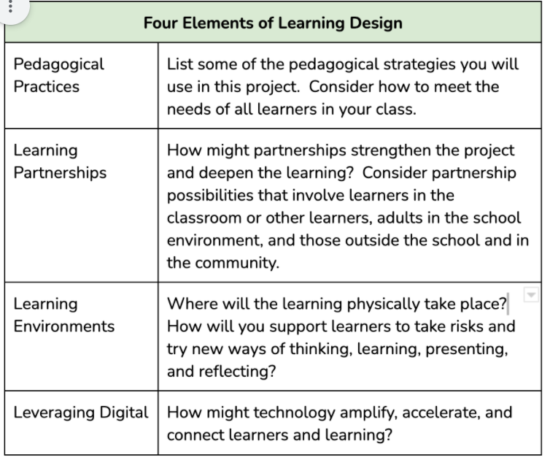
- Pedagogical Practices
- Learning Partnerships
- Learning Environments
- Leveraging Digital
Element 1: How is your project designed with this element in mind?
Element 2: How is your project designed with this element in mind?
Describe the project activities. Explain how they are connected to the Learning Outcomes.
Describe the research or best practices you used in the design of the project.
What new or existing materials/equipment will be required? How will these new or existing materials/equipment be used?

Project Impact
Describe the features of the project that are innovative. (See working definition of innovation here: https://bit.ly/2U8FfTJ)

Describe how your project will engage ALL of your students.

What are some ways your project might be scaled up (replicated in other classrooms or buildings)?

Project Evaluation
What are some ways you will assess learning (include formative and summative assessments)? How will you know the success criteria are being met?

Project Budget and Award Obligations
This section is not scored, but complete information is required for consideration.
Requested Amount (up to $800 x # of teachers applying for this grant):
List detailed cost(s) of items/services to be purchased. Without these cost details, the application will not be funded.
Promoting your grant: The success of a grant program like this is due, in part, to community awareness. We need your help in messaging the community about programs like this. This will allow the Foundation to award more grants and bring greater visibility to the great work done in TSD. Please provide assurance that you have/will commit to the below-listed obligations by checking the following boxes:
- Principal Approval: I have spoken with my principal and she/he approves of this project.
- Evaluation: If selected to receive a grant, I will complete the one-page evaluation from the TFEE in May.
- Grant Reception: If selected to receive a grant, I will attend and prepare a table-top presentation for the TFEE Grant Reception. (This reception will likely take place on Opening Day in August 2022. Of course, all plans are tentative as we navigate the COVID world.)

